What does this Vue warning message mean? Can you safely ignore it? What causes it, and how do you fix it?  Write an answer ***in your own words***.

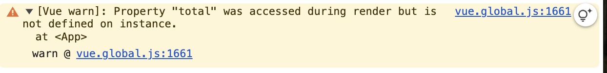

This warning message show up when we try to use a variable that we didn’t define in our code or may be if we made a typo when we create the variable, this warning sign will show up.

We can’t ignore this warning message.

To fix this error, we must define our call in our code and then use it in the html page or check if we made a typo error. If typo is the case, fix the typing error and the error will go away.